Report on lab the 8. Saveli Litvin

# 2. Data Warehouse Architecture

## 2.1. Task 01: CREATE Schema of simple Data Warehouse Architecture

|  |  |  |  |
| --- | --- | --- | --- |
| Level Type | Object Name | Tablespace | Description |
| Storage level  SA_* | SA_CUSTOMERS | ts_SA_CUSTOMERS_DATA_01 | Loading from Flatfile storage system. Contains Customer information |
| SA_PRODUCTS | ts_SA_PRODUCTS_DATA_01 | Loading from Flatfile storage system. Contains Product information, geo location |
| DW - Cleansing Level | DW_CL | ts_DW_CL_01 | Loading from stage level system and preparing information for usage |
| DW – Level | DW_DATA | ts_DW_DATA_01 | Loading data from cleansing stage and preparing it for to the 3rd normal form and available for star scheme building |
| DW– Prepare Star Cleansing Level | SAL_DW_CL | ts_SA_DW_CL_01 | Loading data from DW system. Containts views and objects from DW - Level |
| STAR - Cleansing | SAL_CL | ts_SA_CL_001 | Loading data from dw_cl, but clean some redundancy |
| STAR – Level | DM_FCT_SALES | ts_SA_FCT_SALES_01 | Store information about facts (Weekly Sales) |
| DM_DEALERS | ts_SA_DIM_DEALERS_01 | Store information about DIM_DEALERS |
| DM_GEN_PERIODS | ts_SA_DIM_GEN_PERIODS_01 | Store information about DIM_GEN_PERIODS |
| DM_CUSTOMERS | ts_SA_DIM_CUSTOMERS_01 | Store information about DIM_CUSTOMERS |
| DM_PRODUCTS | ts_SA_DIM_PRODUCTS_01 | Store information about DIM_PRODUCTS |
| DM_GEO | ts_SA_DIM_GEO_01 | Store information about DIM_GEO |

## 2.2.

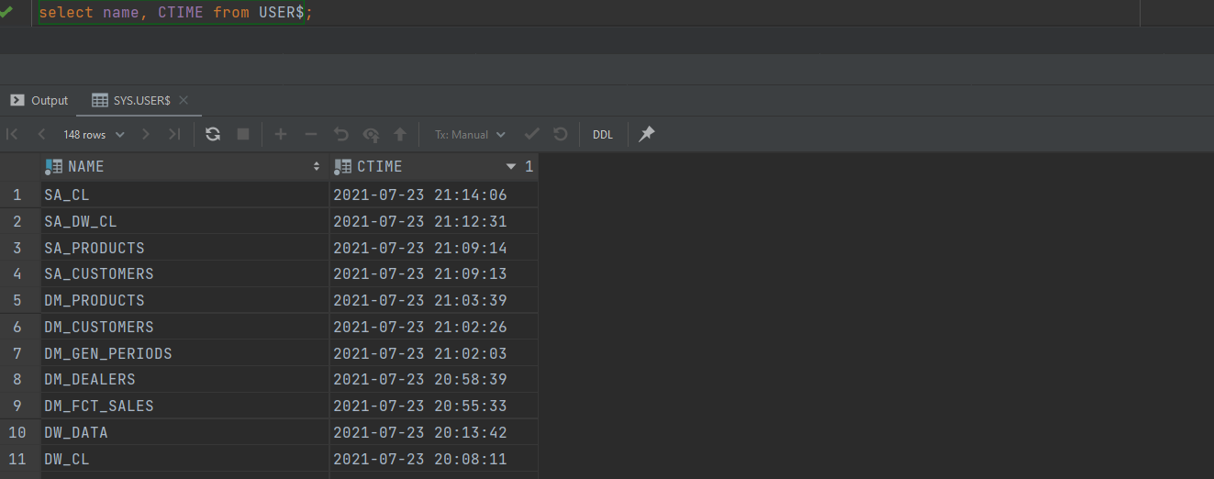

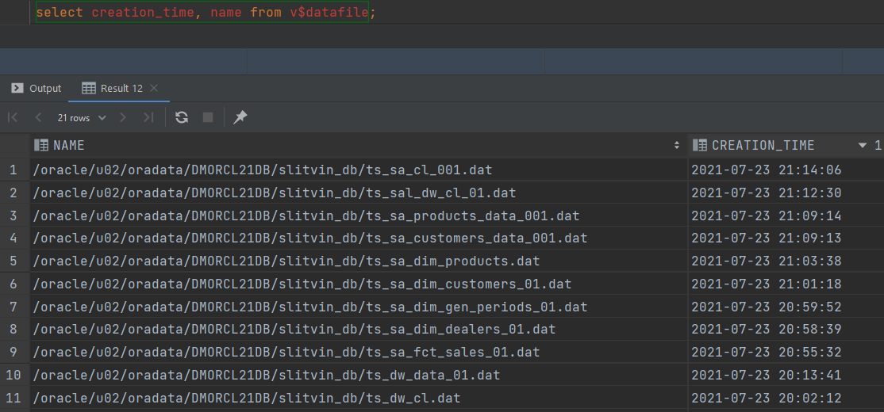

Script on git

# 3. Star – Business analyses task

## 3.1. Task 07: CREATE Prepared Star Objects

Script is alocated in folder or check git

## 3.2. Task 08: DataFlow Diagram

**The Main Task** is to create DataFlow Diagram to describe refresh process of yours Business STAR

**Task Results:**

Create DataFlow Diagram:

* Add chapter to Solution Concept with DataFlow Diagrams

## 3.3. Task 09: Grants Object Privileges

|  |  |
| --- | --- |
| *User* | *Privileges* |
| SA_CUSTOMERS | grant connect, resource to SA_CUSTOMERS; |
| SA_PRODUCTS | grant connect, resource to SA_PRODUCTS; |
| DW_CL | grant connect, resource, create view to DW_CL; |
| DW_DATA | grant connect, resource to DW_DATA |
| SA_DW_CL | grant connect, resource, create view to sa_dw_cl |
| SA_CL | grant connect, resource, create view to sa_cl; |
| DM_FCT_SALES | grant connect, resource, create view to DM_FCT_SALES; |
| DM_DEALERS | grant connect, resource, create view to DM_DEALERS; |
| DM_GEN_PERIODS | grant connect, resource, create view to dm_gen_periods; |
| DM_CUSTOMERS | grant connect, resource, create view to DM_CUSTOMERS; |
| DM_PRODUCTS | grant connect, resource, create view to DM_PRODUCTS |